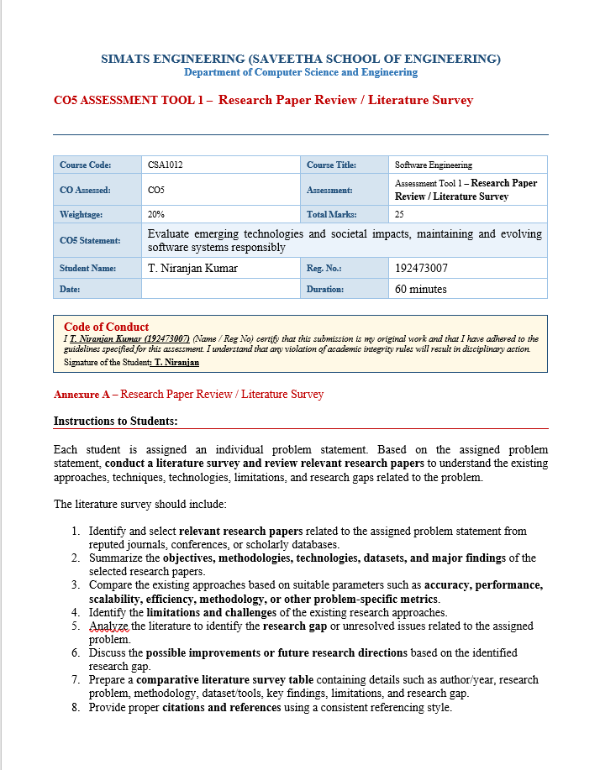

PAPER 1: A Systematic Literature Review on the Barriers Faced by Newcomers to Open Source Software Projects
Paper Citation: I. Steinmacher, T. U. Conte, M. A. Gerosa, and D. F. Redmiles, 2015
Table 1. Detailed Review of Paper 1
Research Objective | To identify and classify the barriers faced by newcomers when contributing to open-source software projects.
Research Problem | Newcomers often give up because they encounter social, knowledge, documentation, and technical barriers before completing a contribution.
Methodology | Systematic Literature Review. The study retrieved 291 studies from four digital libraries and identified 20 primary studies for detailed analysis. Coding inspired by Grounded Theory was used to categorize the reported barriers.
Dataset / Study Source | 20 primary empirical studies selected from the literature review process.
Techniques / Approach | Systematic review, backward snowballing, open coding, axial coding, and barrier categorization.
Major Findings | The study identified 15 barriers grouped into five categories: social interaction, newcomers’ previous knowledge, finding a way to start, documentation, and technical hurdles.
Strengths | Provides a broad and structured understanding of why newcomers struggle and identifies both technical and non-technical barriers.
Limitations | The study identifies problems but does not propose a complete personalized recommendation or centralized contribution tracking solution.
Relevance to Proposed Project | Directly supports the problem statement by identifying the barriers that the proposed recommendation and tracking system should reduce.

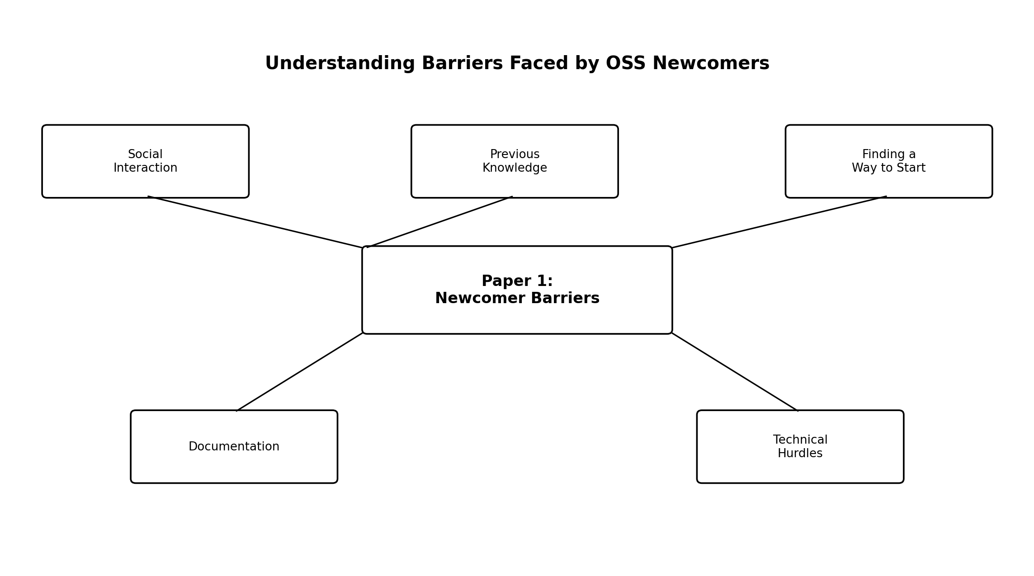
Figure 1. Conceptual Visual Summary of Paper 1

PAPER 2: A First Look at Good First Issues on GitHub
Paper Citation: X. Tan, M. Zhou, and Z. Sun, 2020
Table 2. Detailed Review of Paper 2
Research Objective | To study the use of Good First Issues (GFIs) on GitHub and understand how they support newcomer onboarding.
Research Problem | Although projects label issues as beginner-friendly, a GFI label may not always guarantee that the issue is suitable for every newcomer.
Methodology | Large-scale empirical analysis of GitHub Good First Issues, supported by investigation of issue and project characteristics and developer perspectives.
Dataset / Study Source | 9,368 Good First Issues collected from 816 GitHub projects.
Techniques / Approach | Repository and issue analysis, empirical comparison of GFI characteristics, and investigation of factors affecting newcomer suitability.
Major Findings | GFIs can support onboarding, but issue clarity, limited scope, suitable required skills, and project support are important. A label alone is insufficient.
Strengths | Provides evidence about how beginner-friendly labels are used in practice and highlights the difference between a label and actual newcomer suitability.
Limitations | Does not provide personalized recommendations based on an individual developer's skills, interests, or experience.
Relevance to Proposed Project | Supports the need for skill matching and difficulty analysis instead of relying only on the 'good first issue' label.

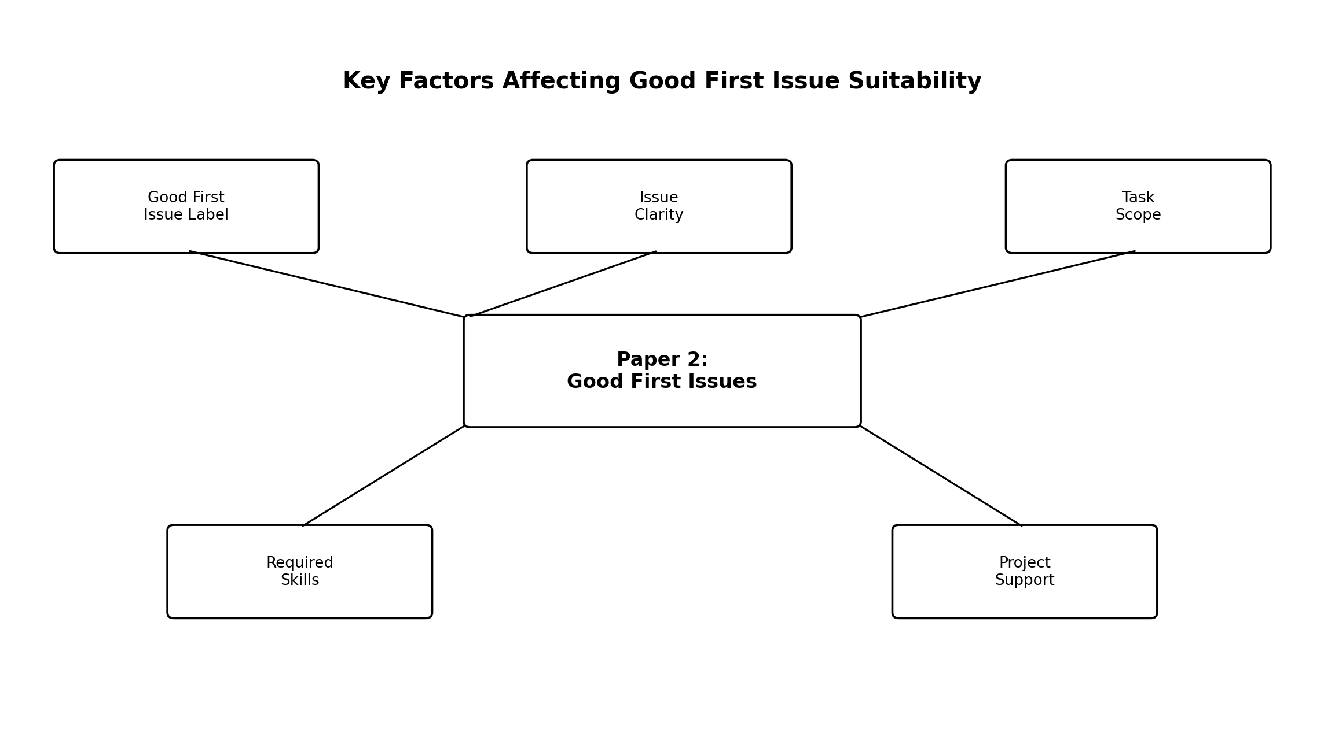
Figure 2. Conceptual Visual Summary of Paper 2

PAPER 3: Recommending Good First Issues in GitHub OSS Projects
Paper Citation: W. Xiao, H. He, W. Xu, X. Tan, J. Dong, and M. Zhou, 2022
Table 3. Detailed Review of Paper 3
Research Objective | To automatically identify and recommend suitable Good First Issues for newcomers in GitHub open-source projects.
Research Problem | Existing manually labelled GFIs can be insufficient or inappropriate, and newcomers may struggle to locate suitable development tasks.
Methodology | The proposed RecGFI models issues using multiple feature dimensions and applies an XGBoost classifier to estimate the probability that an issue is suitable as a GFI.
Dataset / Study Source | 53,510 resolved issues collected from 100 GitHub projects, with historical states restored to construct evaluation data.
Techniques / Tools | Content, background, and dynamics features; XGBoost machine-learning classifier; interpretable model analysis.
Major Findings | RecGFI achieved up to 0.853 AUC and outperformed alternative models. The study also identified open issues predicted as suitable GFIs, some of which were confirmed by project maintainers.
Strengths | Uses a practical machine-learning approach and demonstrates measurable performance for identifying suitable newcomer tasks.
Limitations | Focuses on issue recommendation rather than complete end-to-end support such as personalized long-term tracking, skill dashboards, notifications, and portfolio generation.
Relevance to Proposed Project | Provides the core idea for an automated issue recommendation module and can be extended with personalization and contribution tracking.

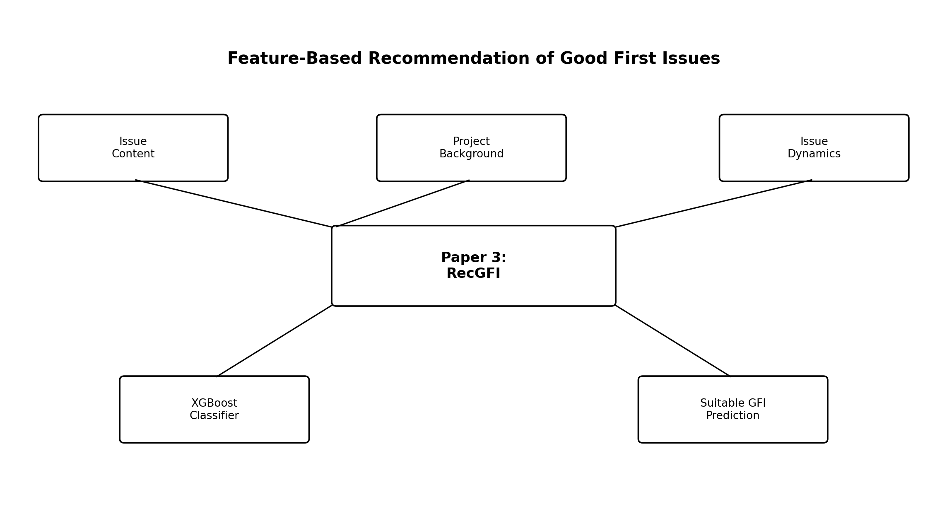
Figure 3. Conceptual Visual Summary of Paper 3

PAPER 4: Personalized First Issue Recommender for Newcomers in Open Source Projects
Paper Citation: W. Xiao, J. Li, H. He, R. Qiu, and M. Zhou, 2023
Table 4. Detailed Review of Paper 4
Research Objective | To recommend first issues that are personalized to the characteristics and background of individual newcomers.
Research Problem | Generic GFI recommenders may mismatch diverse newcomer backgrounds, leading to failed attempts and discouraging onboarding experiences.
Methodology | The researchers analysed 37 newcomers and their first resolved issues, identified influential newcomer and issue features, and proposed PFIRec using LambdaMART for ranking candidate issues.
Dataset / Study Source | 37 newcomers were analysed for behavioural insights; PFIRec was evaluated using 68,858 issues from 100 GitHub projects.
Techniques / Tools | Feature analysis of expertise preference, OSS experience, activeness, and sentiment; personalized ranking using LambdaMART.
Major Findings | Task type, programming language, and project domain showed importance for personalization. PFIRec outperformed existing recommenders and could substantially improve the suitability of top-ranked issues.
Strengths | Moves beyond generic issue recommendation by explicitly considering differences among individual newcomers.
Limitations | Primarily concentrates on finding a suitable first issue and does not integrate centralized activity tracking, notifications, community insights, skill dashboards, or portfolio generation.
Relevance to Proposed Project | Highly relevant because the proposed system also requires personalized matching between a developer's skills and suitable open-source opportunities.

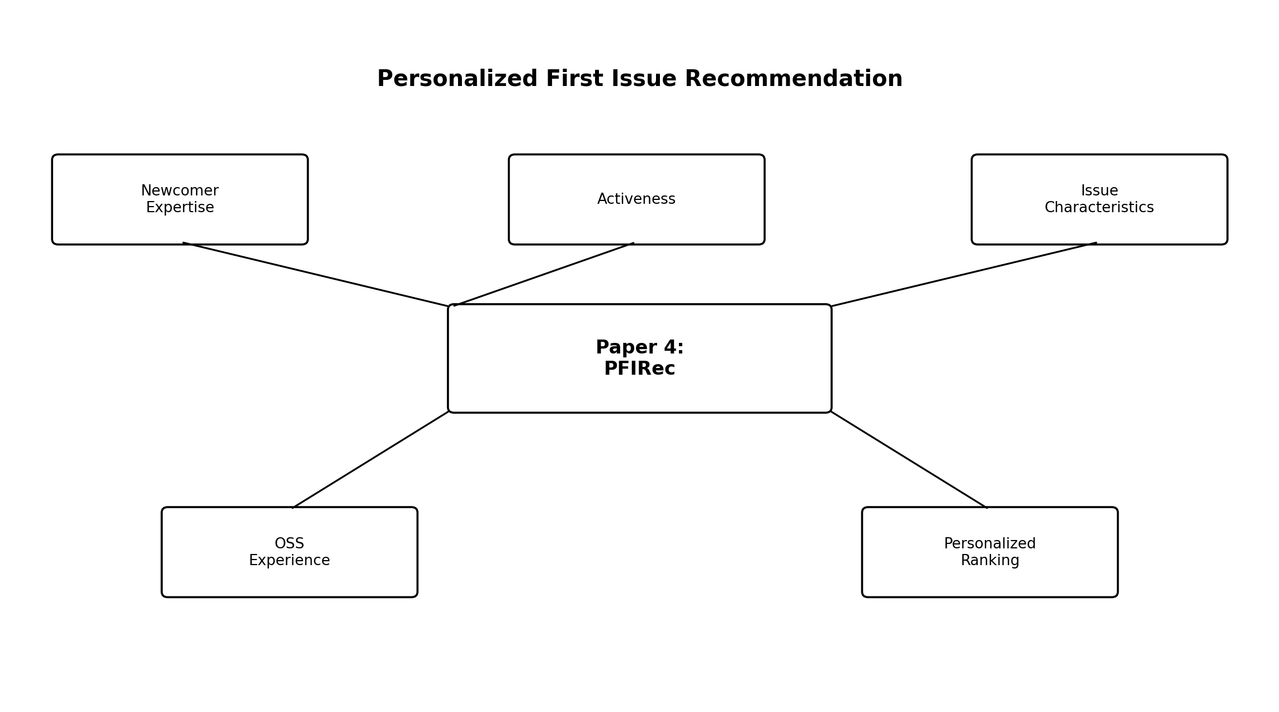
Figure 4. Conceptual Visual Summary of Paper 4

PAPER 5: From First Patch to Long-Term Contributor: Evaluating Onboarding Recommendations for OSS Newcomers
Paper Citation: A. K. Turzo, S. Sultana, and A. Bosu, 2024
Table 5. Detailed Review of Paper 5
Research Objective | To evaluate whether existing onboarding recommendations improve newcomers' successful first contributions and whether they remain useful for long-term contributors.
Research Problem | Many onboarding recommendations are based on limited project contexts, and their generalizability and long-term usefulness are uncertain.
Methodology | Two-stage mixed-method study. First, a Systematic Literature Review identified 15 task-related actionable recommendations. Second, a large-scale empirical study evaluated them across multiple OSS projects.
Dataset / Study Source | Five Gerrit-based projects and 1,155 open-source projects from GitHub.
Techniques / Approach | Systematic Literature Review, empirical evaluation, cross-project analysis, and assessment of associations with first-patch acceptance and contributor progression.
Major Findings | Four recommendations showed positive associations in most contexts, four were context-dependent, four showed negative associations in most projects, and three were newcomer-specific and should be abandoned after the newcomer stage.
Strengths | Examines both successful onboarding and long-term contributor progression across a large set of project contexts.
Limitations | Evaluates recommendations rather than implementing a single integrated platform for personalized recommendation, tracking, skill progression, and portfolio generation.
Relevance to Proposed Project | Supports the need for adaptive recommendations that change as a beginner becomes a more experienced contributor.

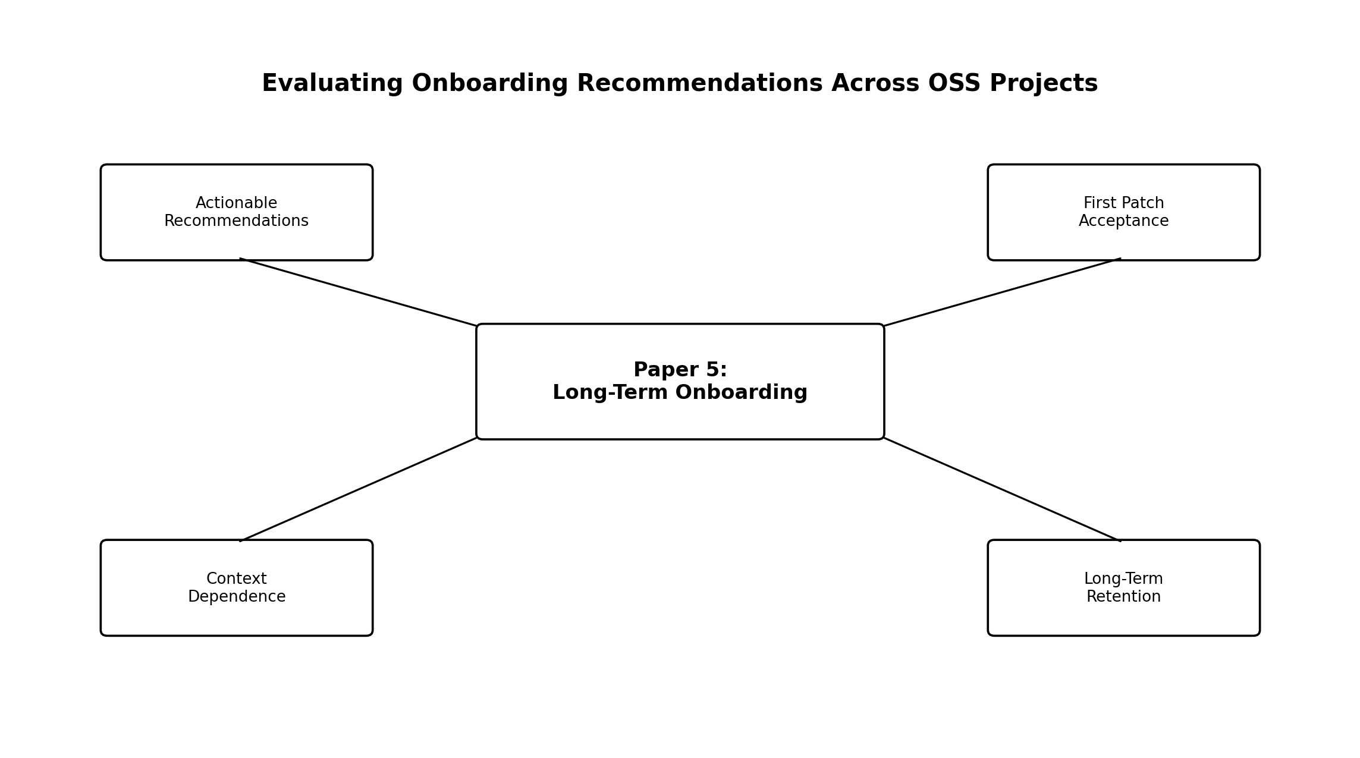
Figure 5. Conceptual Visual Summary of Paper 5

6. Comparative Analysis of All Five Papers
Paper | Main Focus | Core Technique | Personalized Recommendation | Tracking Support | Main Limitation
Paper 1 | Newcomer barriers | SLR + coding | No | No | Problem identification only
Paper 2 | Good First Issues | Empirical GitHub analysis | Limited | No | No individual matching
Paper 3 | Automated GFI recommendation | XGBoost / RecGFI | Generic | No | First-task focus
Paper 4 | Personalized first issues | LambdaMART / PFIRec | Yes | No | No full contribution lifecycle
Paper 5 | Onboarding and retention | SLR + empirical study | Context-aware | No | No integrated platform

7. Overall Research Gap
The five papers collectively provide strong support for understanding and improving newcomer onboarding. However, the reviewed research does not provide one integrated system that combines personalized issue recommendation, dynamic difficulty estimation, centralized pull-request and issue tracking, skill-progression visualization, personalized notifications, community responsiveness insights, and portfolio generation. This integrated end-to-end support forms the main research gap addressed by the proposed Open-Source Contribution Tracker and Recommendation System for Beginner Developers.

8. Future Directions
- AI/ML-based adaptive recommendations that learn from a developer's contribution history.
- NLP-based extraction of required skills and task complexity from issue descriptions.
- Dynamic difficulty scoring that changes as the contributor gains experience.
- Community responsiveness and mentorship analysis for safer project selection.
- Explainable recommendations that show why a particular issue was suggested.
- Automatic portfolio generation highlighting merged pull requests, technologies, and contribution growth.

9. Conclusion
The paper-wise review demonstrates that the research field has evolved from identifying newcomer barriers to providing automated and personalized issue recommendations. Nevertheless, issue recommendation alone does not fully support a beginner throughout the contribution journey. The proposed system extends the reviewed research by integrating recommendations with tracking, progression analysis, notifications, community insights, and portfolio generation.

References
[1] I. Steinmacher, T. U. Conte, M. A. Gerosa, and D. F. Redmiles, “A Systematic Literature Review on the Barriers Faced by Newcomers to Open Source Software Projects,” Information and Software Technology, vol. 59, pp. 67–85, 2015. doi: 10.1016/j.infsof.2014.11.001.
[2] X. Tan, M. Zhou, and Z. Sun, “A First Look at Good First Issues on GitHub,” in Proceedings of the 28th ACM Joint Meeting on European Software Engineering Conference and Symposium on the Foundations of Software Engineering, pp. 398–409, 2020. doi: 10.1145/3368089.3409746.
[3] W. Xiao, H. He, W. Xu, X. Tan, J. Dong, and M. Zhou, “Recommending Good First Issues in GitHub OSS Projects,” in Proceedings of the 44th International Conference on Software Engineering, pp. 1830–1842, 2022. doi: 10.1145/3510003.3510196.
[4] W. Xiao, J. Li, H. He, R. Qiu, and M. Zhou, “Personalized First Issue Recommender for Newcomers in Open Source Projects,” in Proceedings of the 38th IEEE/ACM International Conference on Automated Software Engineering, pp. 800–812, 2023.
[5] A. K. Turzo, S. Sultana, and A. Bosu, “From First Patch to Long-Term Contributor: Evaluating Onboarding Recommendations for OSS Newcomers,” 2024.

